

TICKET TO RIDE TECHNICAL DOCUMENT

[Document subtitle]



**Contents**

**Introduction 2**

**A Flowcharts 2**

**B Technical Specifications 5**

**ROUTE CLAIM SUBSYSTEM 7**

**DRAWING CARDS SUBSYSTEM 8**

**DESTINATION DRAW 9**

**Technical Design Document**

# Introduction

Ticket to Ride is a turn-based strategy board game where players compete to claim railway routes across North America. The objective of the game is to score the most points by connecting cities and completing destination tickets.

For our implementation of Ticket to Ride, we will be building a 2D game using the Unity game engine. The game will support multiplayer with up to 3 players.

A Flowcharts

Draw Card

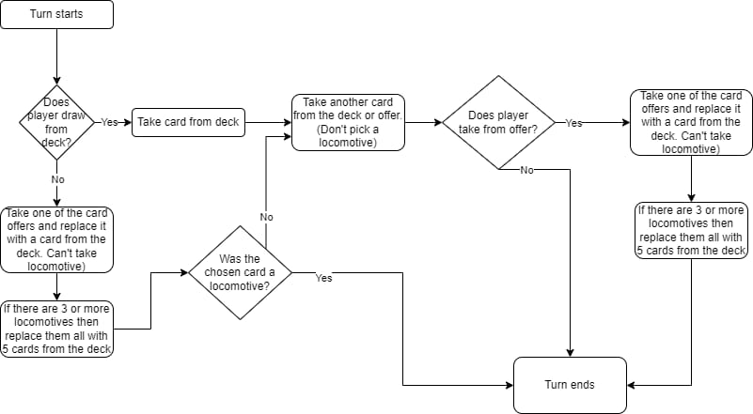

Destination Draw

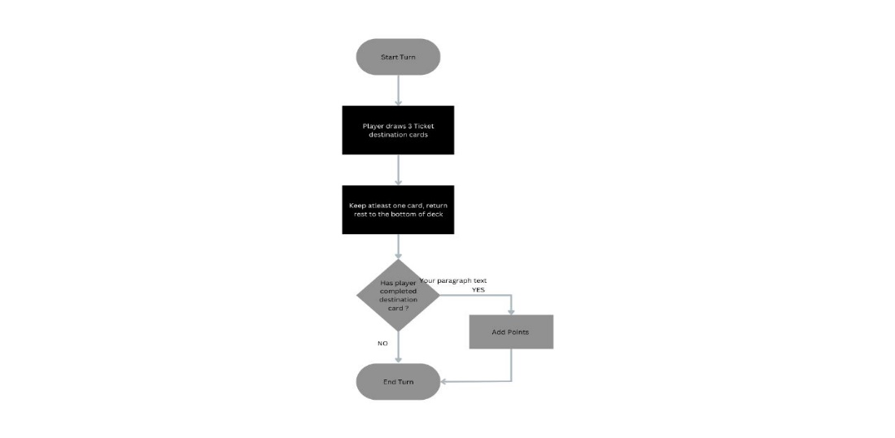

Route Claim

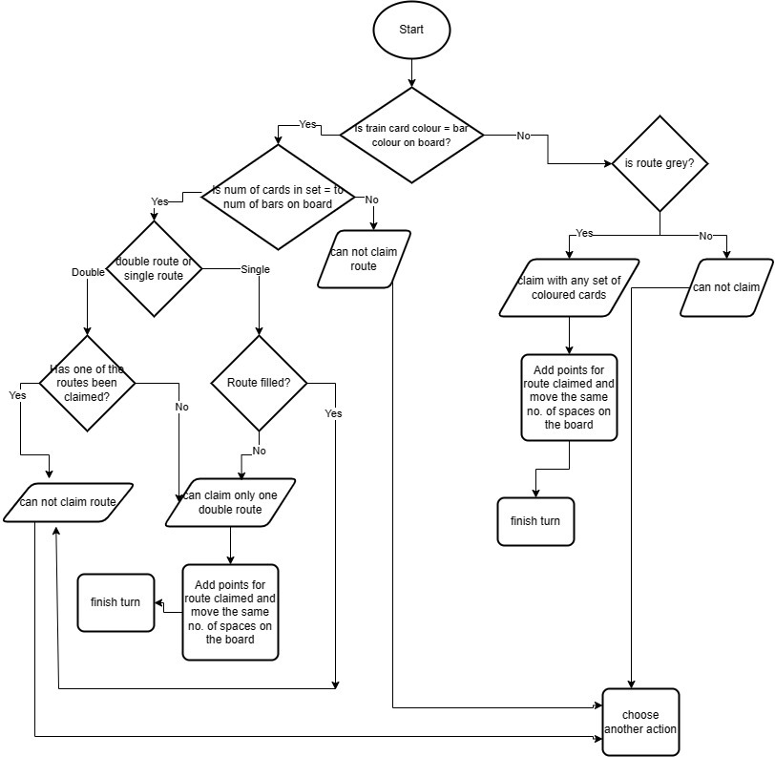

Entire Game

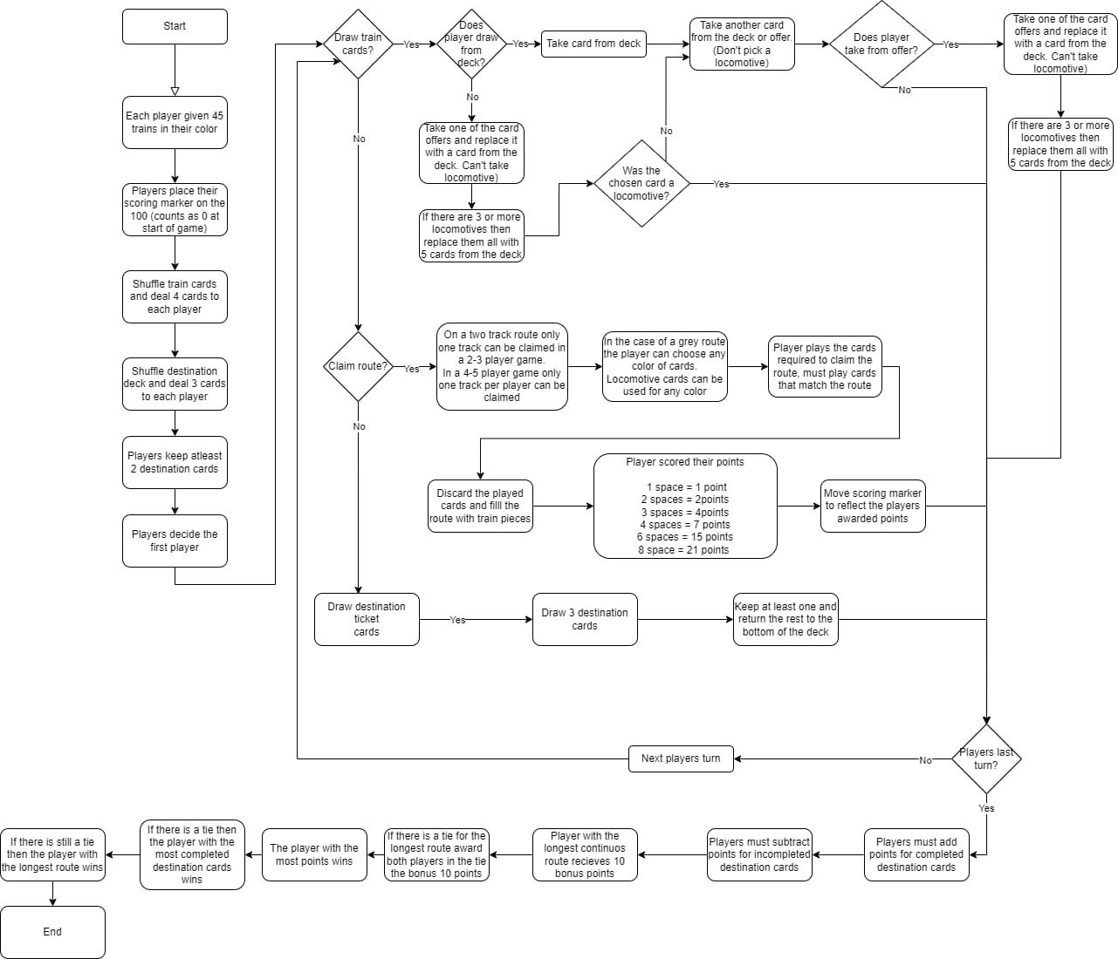

### B Technical Specifications

1. Game Setup:

Each player starts with 45 train cars, 4 train car cards, and 3 destination ticket cards. The remaining train car cards are placed face down in a draw pile, and 5 cards are turned face up to form the train car card market.

1. Turn Sequence:

On their turn, a player can perform one of three actions:

* Draw two train car cards: The player draws two cards from either the face up cards in the train car card market or the top of the draw pile. The player can take two cards of the same color or two different colors.
* Claim a route: The player plays a set of train car cards that match the color and length of a route on the game board. The player places their train cars on the route to indicate that it is now claimed by them. If a route is already claimed by another player, the player must play additional train car cards to claim the route. Each player can only claim one route per turn.
* Draw three destination ticket cards: The player draws three destination ticket cards and must keep at least one of them. The other two cards are placed face down at the bottom of the deck. Destination ticket cards represent a set of cities that the player must connect with their train routes. If the player successfully connects all the cities on a destination ticket, they earn the points indicated on the card. If the player fails to connect all the cities, they lose the points indicated on the card.

1. Game End:

The game ends when one player has two or fewer train cars left. At this point, each player gets one more turn before the final scoring. During this last turn, players can only claim routes that are one or two train cars long.

1. Scoring:

Players score points for the routes they have claimed and the destination tickets they have successfully connected. Players lose points for any destination tickets that they have failed to connect. The player with the most points at the end of the game is the winner.

1. User Interface

Game board: Display the map of Nort America, with the cities, routes and train car placements

Player hands: Showing their train car hands and destination ticket cards held

Train Car : Showing face up trian cards

Scores: Displays all the players score updated with each action.

Current player Indicator : Displays who’s currently having their turn during play

Collected Cards: Indicating the train car cards collected

Claimed routes: On the game board, the claimed routes will be displayed in a greyed out part of the route, or have train cars on top to display.

1. Game mechanics:

The game mechanics of Ticket to Ride will closely follow the rules of the original board game. Players will take turns drawing cards and claiming railway routes on the game board, using their cards to match the colors and lengths of the routes. Players will also have the option to draw destination tickets, which award bonus points for connecting specific cities.

At the start of the game, each player will be dealt a set of train car cards and a set of destination tickets. On their turn, a player can perform one of three actions: draw train car cards, claim a route, or draw destination tickets. Each turn, players will also have the option to discard train car cards to draw new ones from the deck.

The game will end when one player has only a few train cars left or when the train car deck runs out. At the end of the game, players will score points based on the length of the routes they have claimed, the destination tickets they have completed, and any bonus points earned for having the longest continuous route.

The game will be presented in a 2D top-down view, with the game board and player hands displayed on screen. Players will interact with the game using a combination of mouse clicks and buttons on screen.

3 Sub Systems

# ROUTE CLAIM SUBSYSTEM

The route claim subsystem governs the way the players can claim routes based on specific rules and how claiming a route adds to the player’s score.

Before understanding how a route is claimed, it is important to understand what a “route” is in the context of this game. A route is a set of blocks on the board that connect one city to another.

1 **Route Check** On each turn, players can perform three actions, one of which is “to claim a route”. First, the player checks their train cards and finds the routes on the board that match the colour of any of their train cards.

2 **Matching Train Cards** In the case that the player’s train card does not match any of the routes on the board, the player cannot claim a route. In the special case where there is a grey route available on the board and the player owns a set of a specific colour of train cards, the player can use that set to claim the grey route.

3 **Sufficient Card Quantity** The player then needs to check that the number of cards in their set matches the number of blocks their wish to claim on the board. For example, a player cannot claim a route of 5 blocks if they only have 3 cards of that route’s colour. In a similar manner, the player cannot use 5 cards to claim 2 blocks on a route.

4 **Single or Double Route** The next thing the player needs to check is if they wish to claim a single route or double route. In this version of Ticket to Ride, there are only 3 players playing the game. Because of this, only one of the double routes can be claimed at a time by a single player. Once one of the double routes has been claimed by a player, for the rest of the game, the other route (of the double route) can never be claimed by that player or any other player.

5 **Route Availability** If a player wishes to claim a single route, the only thing they need to check is the availability of that route. If those blocks in that route have been filled, then the player cannot claim that single route. If not, the player can claim that route.

6 **Scoring and Token Movement** Once a player has claimed a route, the respective number of points is added to the player’s score and the player moves their token accordingly on the board.

# DRAWING CARDS SUBSYSTEM

This subsystem allows players to acquire more train cards from the deck. Players draw cards to collect the colors they need to claim routes on the board.

There is a deck of train cards containing various colors corresponding to the routes on the board. Players can draw from this deck.

On you turn, you can choose to draw train cards. You’ll have two options as follows

**1 Draw from the Deck:** You can draw the card on the top of the deck to add it onto your own hand. This card is added to your hand, and can be used for your next draw.

**2 Draw from Face-Up Cards:** You can alternatively choose to draw cards that are face up instead of drawing from the deck. These will be visible to the player and are replaced after each draw. This card allows players to strategically choose cards that match the colors they need

Each player has a sort hand to hold the train cards they’ve so far collected. The cards in the hand will represent the resources for claiming routes.

Players also have a limit on the maximum hand. This restricts the number of train cards you can draw at a time. If your limit is reached, you have to discard cards before new ones are drawn.

By drawing the trian cards, your aim is to collect necessary colors to claim routes, manage your hand size and enhance your opportunities of better gamplay an winning.

# DESTINATION DRAW

The destination draw involves players acquiring tickets that specify the routes they need to complete.   
  
There is a deck of tickets that contain the various routes connecting the cities on the board.

1 **Draw Destination Tickets** At the beginning of the game, players can draw a specific number of destination tickets all from the deck. You can choose to keep the drawn tickets or discard some and draw replacements.

2 **Ticket Selection** Players may select destination tickets that they think can help to complete based on the routes they plan on claiming.

**3 Scoring** When the game ends, players are scored based on the completed and uncompleted destination tickets. Completed tickets earn the player the point indicated on the card, while the uncompleted ones will deduct the point value from the player’s score.

SCORING SUBSYSTEM

The scoring is obviously there to calculate and update the players’ scores based on various actions and events during the game.

1 **Route Claim Points** When a player successfully claims a route, they earn points based on the length of the route.

2 **Destination Ticket Points** At the end of the game, players earn or lose points based on their completed and uncompleted routes. This was previously explained in the destination draw system.

3 **Longest Route** Players mainly will compete with each other to have the longest route/s on the board. The player who has the longest route will have an additional number of points, usually 10 or 5 based on the player.

4 **Train Card Penalty** If you happen to have unused train cards remaining in your hand, then you’ll also have a deduction of points on your hand at the end of the game.

Data For Routes

Blue (7 ) routes : Monreal to New York 3 length Atlanta to Miama 4 length Omaha to Chicago 4 length Kansas to St Louis (double route ) 2 length Santa Fe to Oklahoma City 3 length Helena to Winnipeg 4 length Salt Lake City to Portland 6 length Green route (7) Pittsburgh(double) to New York 2 length Pittsburgh to St Louis 5 length Chicago to St Louis ( double ) 2 Little Rock to New Orleans 3 Houston to El Paso 6 San Francisco to Portland 5 Denver to Helena 4 Pink Routes (7) Duluth to Toronto 6 Charleston to Miami 4 Kansas City to St Louis 2 Denver Omaha 4 Helena to Salt Lake City 3 Portland to San Francisco ( one of the double ) 5 San Francisco to Los Angeles 3 ( one of the double) Grey Routes (32) Montreal Boston double ( 2 and 2 ) Toronto, Montreal 3 Toront Pittsburgh 2 Sault Ste Marie Toronto 2 Pittsburgh Washington 2 Raleigh Washington 2 (double 2 and 2 ) Atlanta to Raleigh (double 2 and 2) Atlanta to Charleston 2 Nashville Atlanta 1 St Louis Nashville 2 Kansas City Oklahoma (double 2 and 2) Oklahoma to Little Rock 2 Little Rock St Louis 2 Oklahoma Dallas double 2 and 2 Dallas Little Rock 2 Houston Dallas (double ) 1 and 1 Houston New Orleans 2 Kansas to Omaha (double) 1 and 1 Omaha to Duluth (double ) 2 and 2 Denver to Santa Fe 2 Santa Fe to El Paso 2 El Paso to Phoenix 3 Santa Fe to Phoenix 3 Los Angeles to Las Vegas 2 Seattle to Vancouver double (double ) 1 and 1 Seattle to Portland (double ) 1 and 1 Calgary to Vancouver 3 Calgary to Helana 4 Winnipeg to Sault St Marie 6 Seattle Calgary 4 Phoenix to Los Angeles 3 Duluth to Sault St Marie 3

#### C Visual Composition